
STUDENT CASE STUDY EXECUTION REPORT
Department | CSE
Subject | DSA-2
Academic Year | I-III Semester (2025-26)
Faculty Name | Dr.N.Chaitanya Kumar
Student Name | K.V.A.Advaitha
Roll number | 2520030150
Branch | CSE
Course Outcome | CO-1

Case Study Topic: AirLink Flight Schedule Management using AVL Tree
Work Done Summary:
In this project, we developed a Flight Schedule Management System using an AVL Tree. Flight records were stored and organized by Flight ID, while AVL rotations maintained the tree balance after insertions. The system efficiently displayed flight schedules in sorted order and provided fast search and insertion operations. This project demonstrated the practical application of AVL Trees in managing airport flight schedules effectively.
Implementation Details:
- Created FlightNode class to store Flight IDs.
- Implemented AVL Tree insertion operation.
- Calculated node heights after every insertion.
- Computed balance factor for each node.
- Implemented Left Rotation and Right Rotation.
- Handled LL, RR, LR, and RL balancing cases.
- Performed Inorder Traversal to display sorted schedules.
- Verified AVL balancing after each insertion.
Result: Screenshots/ Output
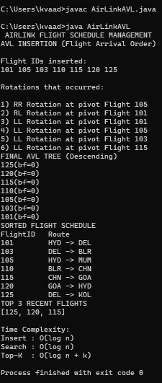
The AVL Tree successfully maintained balanced flight records and generated sorted schedules through in-order traversal.
Time Complexity:
- AVL Insert : O(log n)
- AVL Search : O(log n)
- AVL Delete : O(log n)
- Traversal : O(n)
Compared to a normal BST, AVL Tree ensures balanced performance for airport flight management operations
GitHub Link: https://github.com/advaitha-2307/AirLink-Smart-Airport-Operations-Flight-Management-System
Student Signature | Faculty Signature
________________________ | __________________________

